Fifth Grade Parent Survival Handbook

Overland Trail Elementary School

2018-2019

[](http://www.google.com/url?sa=i&source=images&cd=&cad=rja&docid=NPZQ2GZReIh79M&tbnid=A3pwYS4NvmHidM:&ved=0CAgQjRwwAA&url=http://south-paw.net/&ei=tm4RUpqiMOSr2wXr4ICIBA&psig=AFQjCNGbByH1IWub9Ihb-XdqhsIszAX8tA&ust=1376960566937445)

Lynn Franey

Emily Moore

Miika Schooley

Raquel Thomas

**COMMUNICATION**

* Communication is always the most important piece to help our students have a successful year.
* Tools of Communication include: email, assignment notebooks, or simply writing a note to the specific teacher.
* If students are riding a bus home with a friend, both students need written permission.
* Contact the office and the homeroom teacher for absences, or if your child is taking a different way home.
* Make sure that you have signed up in the office to receive weekly emails from your homeroom teacher and Ms. Druen.
* OTE website: [www.bluevalleyk12.org/ote](http://www.bluevalleyk12.org/ote)

**ASSIGNMENT NOTEBOOKS**

* Students are responsible for recording assignments each day.
* At the end of each class, students will have the opportunity to organize materials and homework that is to be completed that evening.
* Encourage your child to develop the habit of looking at their assignment notebook nightly by asking to see it each day.
* A parent signature is required daily.
* Signatures will be checked daily. 

**END OF THE WEEK FOLDER**

* Folder will go home at the end of each week.
* It may include important papers that need to be signed and returned to school, field trip information, picture information, conference schedules, graded papers, PTO information, Box Top forms, newsletters and other notes.
* Your child’s checkbook will also go home on Friday. There will be a highlighted line after all of the week’s transactions. Please sign on the highlighted line and review the week with your child. Signed checkbooks will be checked on Monday.

**BINDERS**

* Students should bring home their BIG binders every day.
* They will often bring home their 5-subject spiral.
* Because fifth graders are so busy, it is very important that your child keeps their binder organized and neat.
* Worksheets and handouts are color-coded by subject.

Reading= yellow

Math= white

Writing= pink

Science= blue

Soc. Studies= green

* Supplies need to be replenished each quarter, i.e. pencils, red pens, glue sticks, scissors, etc.
* Students will have reading and math homework almost every night. Writing, science, and social studies will mostly have weekly homework.

**SNACKS and BIRTHDAY TREATS**

* Students may bring a healthy, peanut free snack to school since 5th graders have a late lunch.
* Birthday celebrations are appreciated and important, but our focus is on academics.
* NEED TO BE NON-FOOD ITEMS
* Non-food items can include such as pencils, stickers, erasers, magnets, key chains, charms, wrist bands, etc.
* For a full list of ideas, check the 5th grade websites or the OTE website.
* Students will not be allowed to deliver items to other classrooms because it interrupts valuable instruction time.



**SCHEDULES**

* 8:25-8:45 Morning Work, Announcements
* 8:45-9:15 Morning Meetings/Small Groups
* *Band- Mr. Gervais: 8:30-9:15am at OTM Mondays and Wednesdays- Brass*

*Tuesdays and Thursdays- Woodwinds*

* *Orchestra- Mr. Phalps: 8:30-9:15am at OTM- Mondays, Wednesdays, Fridays*
* 9:45-10:45 Specials
* 10:50-11:50 Differentiation Hour
* 11:50-12:50 MATH
* 12:50-1:10 ELA/ILit
* 1:15-1:45 Lunch
* 1:50-3:15 ELA/ILit
* 3:15-3:25 Assignment Notebooks
* 3:25-3:35 Clean Up/ Pack Up/Dismissal

**MATH**

* Students will study math using the *EnVision* series.
* Materials are structured into 16 Topics that last about 1-2 weeks.
* Each topic is focused around critical content areas to help students learn important sets of related mathematical ideas and to become skillful at using these ideas to solve problems.
* The skills will build upon each other from topic to topic.
* Students will learn to communicate their strategies and their reasoning to increase mathematical understanding.
* Independent Practice, Problem Solving, and homework are more challenging and interesting than what our students may have experienced in the past.
* Our main goal is to help our students be successful and to enjoy mathematics.
* [www.pearsonsuccessnet.com](http://www.pearsonsuccessnet.com)



**ELA and ILit**

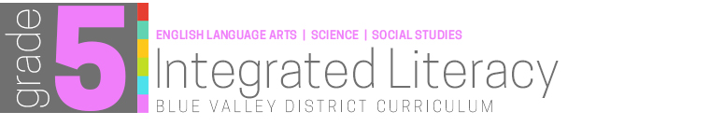

* **Personalized literacy through adaptive performance-based instruction that influences reading growth and steadily increases the capacity to read more complex texts.**



* **Engages, connects and motivates students to improve reading and listening comprehension, writing, and vocabulary across all literacies.**

**C:\Users\Owner\AppData\Local\Microsoft\Windows\Temporary Internet Files\Content.IE5\KSUH3V3A\MC900019306[1].wmf**

**READING and WRITER’S WORKSHOP**

READING-Benchmark Advance

* Acceleration
* Integrates Science and SS
* Literary and Informational Texts
* Whole Group and Small Group Instruction
* Reader’s Theatre

BENCHMARK WRITING

* Literary, Opinion, and Informational Writing
* Mentor Texts
* Grammar
* Spelling/Vocabulary
* Students will publish informational, persuasive, biographical, and narrative writing.
* Small units of grammar will also be studied throughout writing: nouns, verbs, commas, adjectives, types of sentences and structure, prepositions.

**SCIENCE**

* Resource Materials: Science Alive & TCI
* Emphasizes a “hands-on” approach to science.
* Student centered lessons.
* Discovery of decomposers, consumers, and producers in a healthy ecosystem.
* Studies include the geosphere, hydrosphere, atmosphere, and biosphere and learn how these systems interact.
* Develop models to examine patterns caused by the relative positions of the Earth and the sun, and identify matter as particles of matter.

**SOCIAL STUDIES**

* + **Colonization**
  + **Declaration of Independence**
  + **Revolutionary War**
  + **Constitution**
  + **Government**
  + **Bill of Rights**
  + **Economics**
  + **Studies Weekly**

**DIFFERENTIATION**

* Focusing on the individual student growth.
* Small groups are based on the needs of our students.
* Groups will rotate each quarter to give every student an extension of core areas.
* Focus will be Math, Reading, Writing, and STEM.
* Nonfiction text, such as, Science and Social Studies Readers, Math Readers.
* Students will participate in project-based learning for hands-on learning and to reinforce instruction.

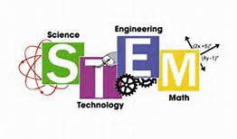

**C:\Users\Owner\AppData\Local\Microsoft\Windows\Temporary Internet Files\Content.IE5\AOELBFGH\MC900320416[1].wmfDISCIPLINE PLAN AND EXPECTATIONS**

* Tied to “Great Expectations” and the banking system, which correlates with the Economics Unit in social Studies.
* It provides a real world application that allows students to take responsibility for their actions.
* Students are given checking accounts in which they receive weekly paychecks from their teacher.
* Students are given opportunities to receive bonuses to increase their balance throughout the quarter.
* Students will be fined for not following the school-wide “Cougar Expectations” and/or the academic or behavioral expectations of 5th grade.
* Students will use money they accumulate in their checking accounts to purchase rewards, such as the Quarter Parties and Semester Auctions.
* By keeping track of the money in their accounts, students can easily see the outcomes of their behavior.
* Checkbooks will need to be signed weekly

# MCj03825860000[1] *GREAT*

**Our Rights and Responsibilities**

***EXPECTATIONS***

## Fifth Grade Constitution

***Responsibility: I have the right to learn; therefore…***

*1. It is my responsibility to have all the supplies I need for class.*

*2. It is my responsibility to complete and turn in assignments on time.*

*3. It is my responsibility to be in my seat and ready to begin class on time.*

*4. It is my responsibility to listen to directions, work quietly, and try my best.*

*5. It is my responsibility to turn in all papers requiring a parent signature on time.*

### Interactions: I have the right to be treated kindly and with

***respect; therefore…***

*6. It is my responsibility to treat others with kindness and respect.*

*7. It is my responsibility to treat my teachers and other adults with respect.*

*8. It is my responsibility to talk at appropriate times.*

***Safety: I have the right to be safe; therefore…***

*9. It is my responsibility to be careful, not hurt others, and to report any unsafe behavior.*

***Surroundings: I have the right to a clean school; therefore…***

*10. It is my responsibility to respect my property and the property of others.*

We, the students of the fifth grade, in order to form a better classroom, create a more caring environment, have a better place to learn, and create more responsible students, do establish this Constitution of Rights and Responsibilities.

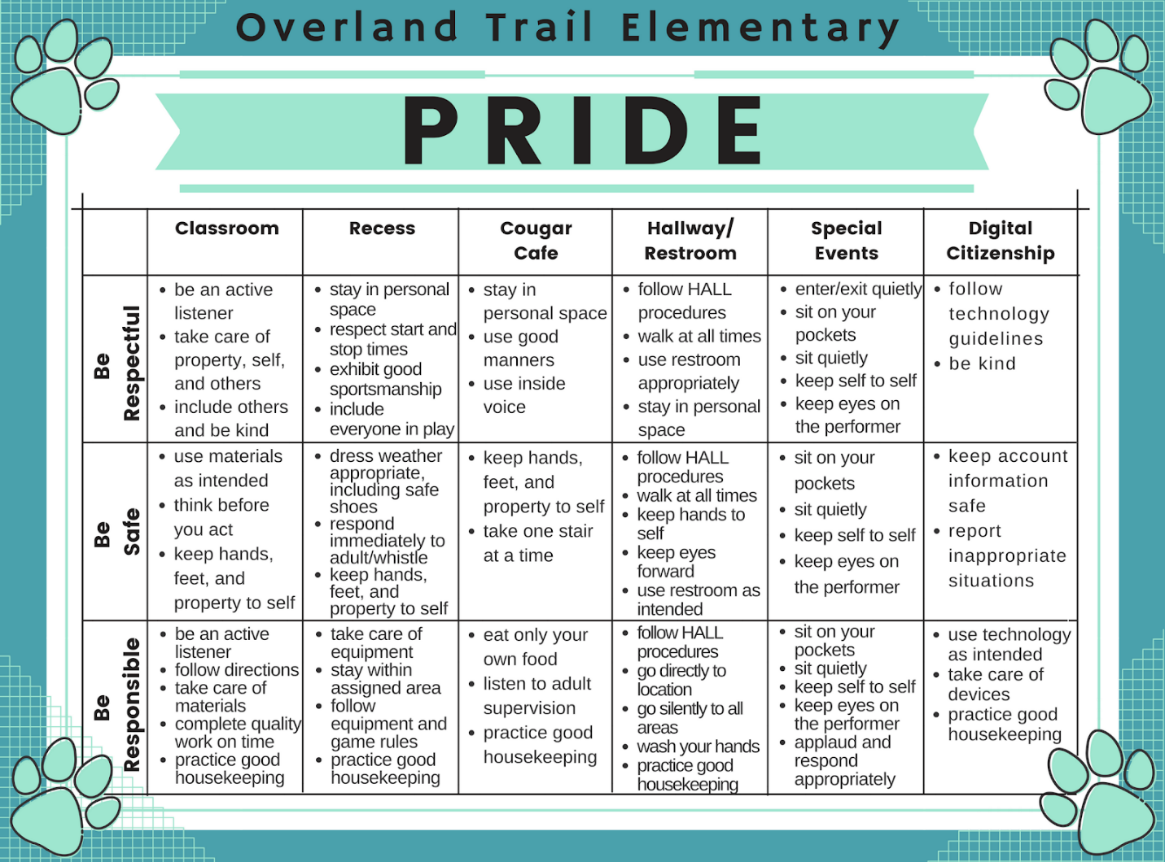

**WHAT CAN PARENTS DO?**

***“THE FIRST TEACHERS ARE THE PARENTS, BOTH BY EXAMPLE AND CONVERSATION.”***

* Help your child stay organized: “Show me your homework”.
* Provide a quiet, study place.
* Encourage them to work honestly with other students.
* Help develop a positive attitude.
* Invite your child to tell you about their techniques related to study skills.
* Share your information and strategies.
* Look for activities and websites related to subjects.
* Communicate with the teacher.
* Students need to communicate with their teacher.
* Share your concerns and acknowledge celebrations.
* Read and sign papers that require a signature.
* Work with your child at home.
* Ask questions about how to solve problems.
* Reflect on your child’s solutions.
* Respond positively.

**CONFERENCES**

* Conferences- Sign Up Genius
* Link was emailed in my weekly announcements
* Fall and Spring conferences will review student progress and identify academic goals.

**VOLUNTEERS**

* Parents will be informed via email when we have specific needs for volunteers for field trips and projects.